**Observation**

Inspection was undertaken at the subject property in the presence of the Insured to which the following was noted:

## Observed Damages

1. The pool has uplifted resulting in the coping paver to also uplift with the pool shell as well. **Images 3 – 4**
2. We also noted cracking and deflection within the southern side of the pool shell. **Images 5 – 6**
3. The Insured also advised that the pool floor has deformed and is drummy underneath.

## Review of Historical Nearmap Imagery

## Cause of Observed Bulging

1. The Insured has advised that there have not been any issues with loss of water from the pool which indicates that there are no issues with the pool plumbing or leaking from the pool shell.
2. As such, in our opinion, the observed damages are not a result of issues with the pool plumbing.
3. From review of the Bureau of Meteorology (BOM) weather records for Norah Head (approximately 15km from the subject property), approximately 300mm of rain fell from 7 – 10 February 2020, refer to ***Appendix A***.
4. The Insured has advised that during the storm event the pool was required to be drained twice to restore the water level back to normal.
5. This indicates the significant volume of water which has inundated the pool and the surrounding pool area as a result of the storm event.
6. We noted a strip drain adjacent to the rear of the house however, in our opinion, this is not sufficient to adequately drain surface water within the pool area during the subject storm event. **Image 7**
7. As such, in our opinion, the significant volume of rain water has resulted in the pool and the surrounding pool area becoming flooded without adequate provisions for surface drainage.
8. Given the insufficient surface drainage the flood water has been able to ingress through the permeable pool pavement into the underlying soil.
9. This water ingress creates a significant increase in hydrostatic pressure around the pool shell which has been illustrated as ***Figure 2*** below.

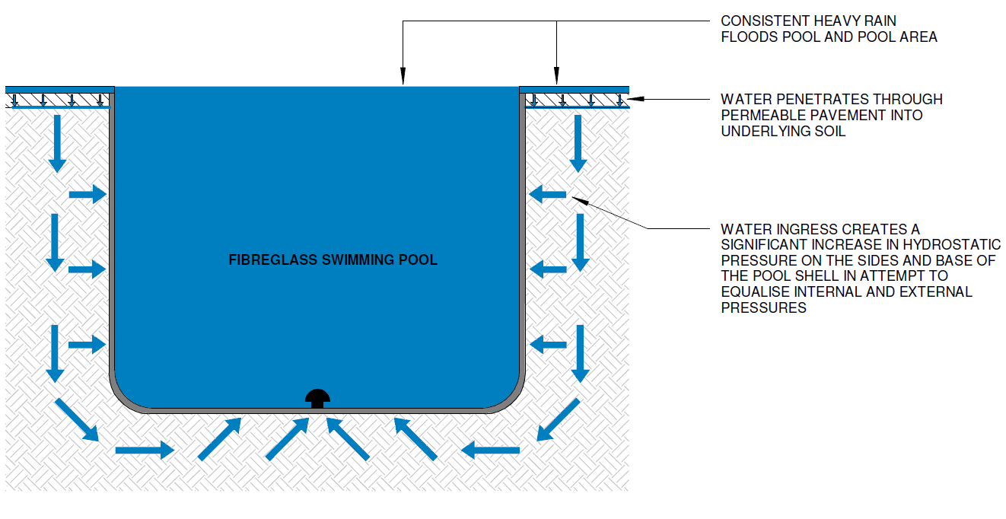

***Figure 2: Flooding of Pool Area Causes Water to Ingress into the Underlying Soil and a Significant Increase in Hydrostatic Pressure Around the Pool Shell***

1. With reference to *AS1838 – 1994 Swimming pools – Premoulded fibre-reinforced plastics – Design and Fabrication*, it states that “*Pools may be subject to external hydrostatic pressures, even though a hydrostatic valve is incorporated in the pool floor. Build-up of this pressure may be avoided by the incorporation of sub-surface drainage (see AS/NZS 1839)”,* refer to ***Appendix B***.
2. It was noted that a hydrostatic valve was installed on the base of the pool. **Image 8**
3. However, in our opinion the hydrostatic value has been has not functioned as intended.
4. As such, in our opinion, the dysfunctional hydrostatic valve creates a build-up of hydrostatic pressure on the pool floor resulting in the observed lifting of the pool shell.
5. The observed lifting of the pool creates unsupported areas underneath the pool which was confirmed by the Insured who indicated that areas below the pool had become deformed and drummy.
6. Furthermore, with reference to *AS1839 – 1994 Swimming pools – Premoulded fibre-reinforced plastics – Installation,* it is a requirement that subsoil drainage be provided to ensure that hydrostatic pressure does not damage the pool, refer to ***Appendix C.***
7. In our opinion, subsoil drainage has been omitted during the construction of the pool which is required to intercept ground water.

1. As such, in our opinion, water ingress into the soil from the storm event has not been able to be effectively and adequately drained resulting in a significant increase in hydrostatic pressure on the pool walls causing the observed deflection and cracking within the southern pool wall.
2. In summarising the cause of the observed damages outlined above we provide the schematic diagram ***Figure 3*** below.

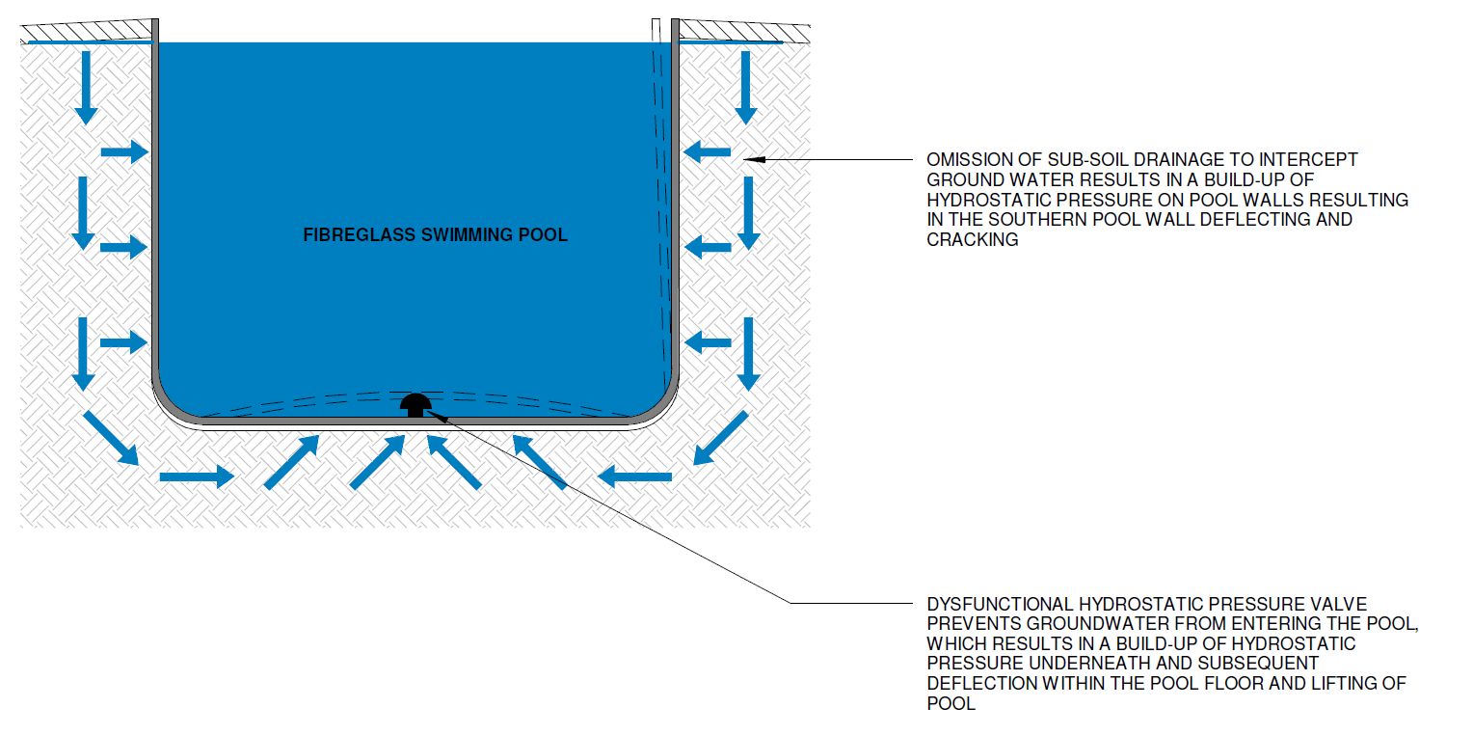

***Figure 3: Cause of Observed Damages to the Pool***

1. To this end, in our opinion, the cause of the uplifting in the pool and the deflection and cracking of the southern pool wall is a result of a build-up of hydrostatic pressure due to the following issues:

* Inadequate surface drainage around the pool area.
* Omission of subsoil drainage during the construction of the pool.
* Lack of regular Maintenance of the Pool to Ensure as evident with the nearmaps images to ensure consistent pool water level

**Discussion**

NA

**Conclusion**

The insured has confirmed that there have not been any issues with water loss from the pool which indicates that the observed damages are not a result of issues with pool plumbing.

From BOM records approximately 300mm of rain was observed in Norah Heads between 7 – 10 February 2020 which is approximately 15km away from the subject property.

In our opinion, the subject storm event has resulted in the pool area becoming flooded as a result of insufficient surface drainage around the pool area allowing flood water to ingress through the permeable pool pavement into the subsoil creating a significant increase in hydrostatic pressure around the pool shell.

Generally, inground shell swimming pools contain a hydrostatic relief valve at the base which functions to equalise the differential water head and regulate differential hydrostatic pressure between the internal and external sides of the pool.

In our opinion, the observed uplifting of the pool shell indicates that the existing hydrostatic relief valve was incorrectly installed/dysfunctional which had caused the excessive hydrostatic pressure from the groundwater to push up the base without entering the pool and deform the lining.

Furthermore, with reference to *AS1839 – 1994 Swimming pools – Premoulded fibre-reinforced plastics – Installation,* it is a requirement that subsoil drainage be provided to ensure that hydrostatic pressure does not damage the pool shell, which in our opinion, has been omitted during the construction of the pool.

As such, in our opinion, water ingress from the subject storm into the subsoil about the pool has resulted in a build-up of hydrostatic pressure causing the observed deflection and cracking within the southern wall of the pool.

To this end, in our opinion, the cause of the uplifting in the pool and the deflection and cracking of the southern pool wall is a result of a build-up of hydrostatic pressure due to the following issues:

* Inadequate surface drainage around the pool area.
* Dysfunctional hydrostatic pressure valve.
* Omission of subsoil drainage during the construction of the pool.